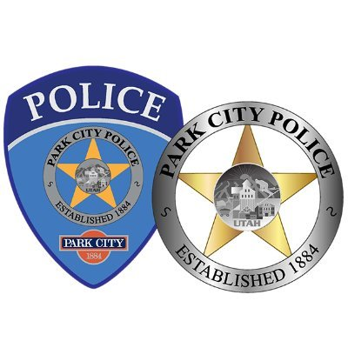


Email us anytime at pcparking@parkcity.org
For after hours parking concerns between 10pm and 8am call Park City Police Summit County Dispatch (non-emergency)
435-615-3607

For general parking questions and requests between 8am and 5pm call our Office
435-615-5301

For general parking questions and patrol requests between 5pm and 10pm call
or text! an on-duty Parking Officer
435-640-6906

Know Who to Call and When!

